UNIVERSITY OF DAR ES SALAAM


COLLEGE OF INFORMATION AND COMMUNICATION TECHNOLOGY
DEPARTMENT OF ELECTRONICS AND TELECOMMUNICATIONS ENGINEERING
FINAL YEAR REPORT – MID SEMESTER ONE
PROJECT TITLE: DESIGN AND IMPLEMENTATION OF AN AUTOMATIC ID CARD ISSUANCE SYSTEM

Student’s Name: Samuel Dan Musyani
Registration Number: 2022 – 04 – 09050
Supervisor’s Name: Dr. Hashimu Iddi
Supervisor’s Signature:

ABSTRACT
The issuance of student identification cards in many higher learning institutions is often characterized by long processing times as a result of manual verification within a narrow working window. This project proposes the design and implementation of an automated self-service student ID card issuance system aimed at improving efficiency, security and all-time reliability of issuance process. The system is an embedded system with peripheral devices for user authentication, data collection, card issuance, back-end communication together with database access. The proposed project will be evaluated based on authentication success rate, dispense rate, issuance accuracy, and system’s reliability.
The outcome of this project is expected to be a functional prototype demonstrating an automated secure student ID card issuance system suitable for University environments.

TABLE OF CONTENTS
ABSTRACT ii
TABLE OF CONTENTS iii
LIST OF ABBREVIATIONS iv
CHAPTER ONE: INTRODUCTION 1
1.1 BACKGROUND 1
1.2 PROBLEM STATEMENT 1
1.3 MAIN OBJECTIVE 1
1.4 SPECIFIC OBJECTIVE 1
1.5 SIGNIFICANCE OF STUDY 2
1.6 SCOPE AND LIMITATIONS 2
CHAPTER TWO: LITERATURE REVIEW 3
2.1 RELATED PROJECTS 3
2.2 RESEARCH GAP 3
CHAPTER THREE: SYSTEM DESIGN AND METHODOLOGY 4
3.1 SYSTEM ARCHITECTURE 4
3.2 FUNCTIONAL WORKFLOW 5
3.3 COMMUNICATION PROTOCOL 5
3.4 HARDWARE AND TOOLS USED 6
3.5 COMPUTER VISION DESIGN INTEGRATION 6
3.5.1 DESIGN DETAILS 7
3.5.2 PROCESSING PIPELINE 7
3.6 BACK – END AUTHENTICATION DESIGN 7
3.7 PROJECT SCHEDULE 8
3.8 PROJECT BUDGET 9
REFERENCES 10

LIST OF ABBREVIATIONS
ABBREVIATIONS | LONG FORM
API | Application Program Interface
DB | Database
ID | Identification
IoT | Internet of Things
OTP | One Time Password
PWM | Pulse-Width Modulation
PVC | Poly-Vinyl Chloride
SMS | Short Message Service
Wi-Fi | Wireless Fidelity
OCR

CHAPTER ONE: INTRODUCTION

1.1 BACKGROUND
Universities commonly issue student ID cards that serve as proof of registration and campus identification for various services to students. At the University of Dar es Salaam, the card collection process, which occurs immediately after students have completed registration, involves queuing at the responsible office for collection. However, for a high volume of students, this results in long waiting times, narrow service windows (only operating during working hours), and staff exhaustion.
Therefore, the project aims to develop a prototype of an Automated ID Card Issuance System that sorts and gives out pre-printed ID cards to students on demand at all times. The system integrates a microcontroller that controls actuators in real-time, a single-board computer that performs computer vision (for ID identification), authentication based on SMS pin serving as OTP, logging of various activities, and back-end integration. The intended solution aims to reduce distribution time while ensuring secure ID card distribution as it is.

1.2 PROBLEM STATEMENT
The current student ID card issuance process at University of Dar es Salaam involves a waiting period of approximately one week after registration due to delayed card availability in the individual’s college. After release, the card collection also requires students to queue and sort a bunch of ID cards. So, for a high volume of students, the staff responsible suffers significant work strain. On top of that, fixed hours also hinder the sorting capacity of students' issuance per time. As a result, card issuance for registered students takes up to several days, which may bring inconvenience to students.

1.3 MAIN OBJECTIVE
Design and implementation of an Automated ID Card Issuance System for pre-printed student ID cards with secure authentication and audit logging while serving students at all times.

1.4 SPECIFIC OBJECTIVE
- To implement a reliable control system for actuators using a microcontroller capable of selecting and dispensing a single card from a pile of cards in a stored compartment.
- To implement a computer board application that gives out authentication OTPs, receives the user registration data, verifies it against a database, and communicates the command to the microcontroller.
- To implement robust logging of each transaction details in database for auditing and debugging.
- To implement security policy that uses SMS-delivered OTPs as authentication mechanism, and also enforce measures to deal with invalid attempts and communication to system admin.
- To evaluate system performance using metrics such as average card retrieval time, authentication success, error handling and dispense rate.
- To produce a formal report involving design of the prototype at various milestones.

1.5 SIGNIFICANCE OF STUDY
- Operational efficiency: the proposed system reduces long queues and waiting times by allowing students to retrieve ID cards on demand without any staff intervention.
- Reduced administrative burden: the system performs automation which replaces the repetitive tasks done by a university staff allowing them to focus on higher level tasks.
- Scalability, accessibility and replicability: Although the proposed system is implemented as a prototype for UDSM, the system can be adopted by other institutions such as banks for card applications. Also, access to students retrieving their ID cards beyond standard normal working hours.
- Academic contribution: the project demonstrates practical application of embedded systems, back-end software and other mechanical design theory and automation studied as theory in various academic year(s).

1.6 SCOPE AND LIMITATIONS
This project focuses on the design and implementation of an Automated ID Card Issuance System which integrates the software part (back-end, user interaction and computer vision verification) and hardware part with microcontroller and actuators for card sorting and dispensing the said card. Therefore, the prototype does not implement on-device printing of the PVC cards, mobile application or payment gateway.
The system intends to use a mock database for testing unless institutional access is granted.

CHAPTER TWO: LITERATURE REVIEW
In this chapter, various existing systems, projects and technologies related to the proposed project are reviewed. The purpose of the review is to understand different approaches, scope, limitations and gaps and hence, establish basis of the proposed project. Therefore, the following points gathered below feature ideas with similar concepts as the proposed project.

2.1 RELATED PROJECTS
- Automatic and Smart Vending systems: these are some self-service systems that provide mostly goods (foods) to users without much human intervention, mostly observed in supermarkets for snacks and beverages. These systems have two categories: non-IoT machines, which operate by giving physical cash to the machine, and IoT machines, which work with cashless payments and track the availability of stock, locations to satisfy customer preferences by using microcontrollers (Ratnasri & Sharmilan, 2021). Also, some vending systems apply image processing with deep learning to detect and categorize various target objects of interest in the image. These kinds of vending machines also implement a weight data acquisition part to increase the accuracy of target object detection (Xia, K., Fan, H., Huang, J., Wang, H., Ren, J., Jian, Q., & Wei, D).
- System architectures and control strategies: in most of the dispensing applications, generally a microcontroller is used with a communication module, mostly Wi-Fi, with a logic to directly manage actuator control, sensor inputs, safety interlocks, and communicate with the server or a computer for other complex tasks (Prasad, Kumar, Shriram, Prof. Dr. Mane, 2024).
- Authentication and security: this is one of the most critical part of the system that deals with sensitive items. In automated environments, combining multiple verification layers (e.g OTP, biometrics, card scanning) improves security. In ATM systems, work on authentication explores multi-factor approaches, integrating OTPs with biometric factors to reduce unauthorized access risk (Kibaya, Lubobya, 2024).

2.2 RESEARCH GAP
From the related projects, the proposed system aims to cover the gap that despite an extensive research on vending and kiosk systems, limited number of projects addresses secure low-cost automated distribution of pre-printed identification cards particularly in University environments.

CHAPTER THREE: SYSTEM DESIGN AND METHODOLOGY
This chapter reviews various procedures to design, build and evaluate the performance of the prototype. It covers system architecture, hardware and software selection together with some security measures.

3.1 SYSTEM ARCHITECTURE
High-level controller will be used to control the user interface, network connectivity, SMS OTP generation (via SMS gateway), database access, computer vision verification, transaction logging, and command issuing to the real-time controller. Then, a real-time controller will be used to directly control the motor (PWM), safety monitoring (limit switches), status reporting, and mechanical card sorting and ejection.
The pre-printed cards will be organized in indexed storage sections, which will be mapped to existing barcodes on the ID cards. Local (mock) database will be used to replicate the University DB scheme, and testing will emulate that unless permission is granted to access the database (API).
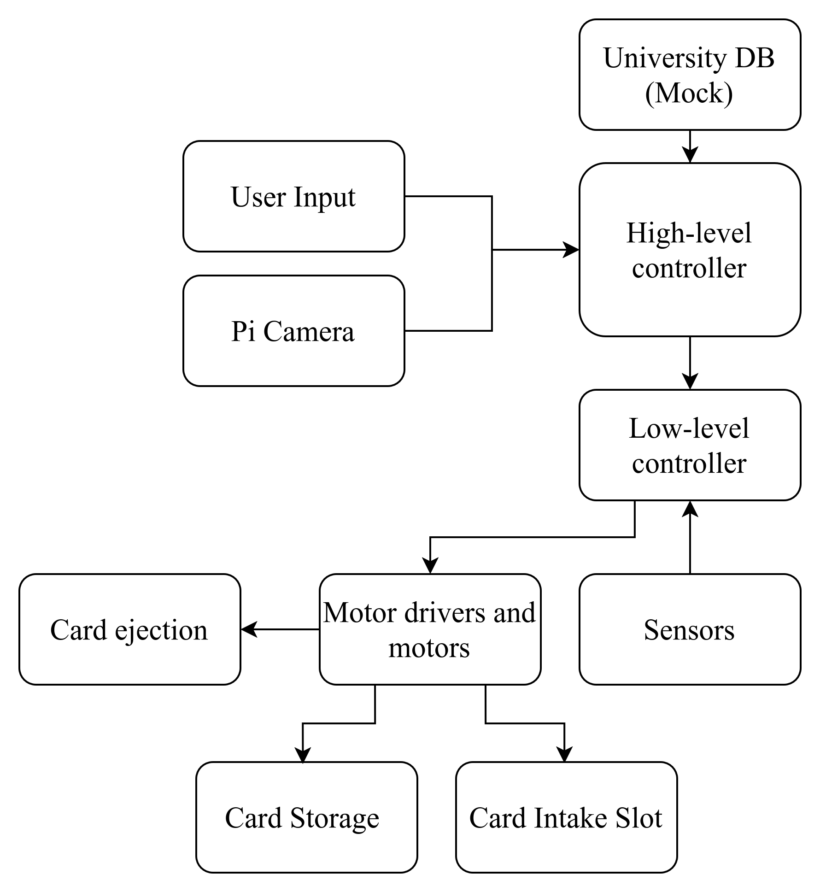
System’s block diagram

3.2 FUNCTIONAL WORKFLOW
- Preload phase: responsible staff inserts a bunch of pre-printed cards into the dispenser, then the machine runs a routine scan and maps each card into a slot index in the dispenser DB. The high-level controller records the mapping with the individual card.
- Notification phase: when the cards are available, right after the routine scan, the high-level controller initiates triggering of SMS to particular students. The SMS includes an OTP valid for one retrieval attempt.
- Retrieval phase: First, students scan their expired card, and their information is shown on the screen (registration number, name, and degree programme), then an OTP prompt follows, as received from the SMS. Thereafter, the high-level controller validates the OTP and sends the dispense command to the low-level controller to start the card dispensing process. The low-level microcontroller executes the motion to retrieve the card and verifies the card and its presence, and performs ejection while updating and returning the status to the high-level controller. Lastly, the high-level controller logs the transaction to the database as the audit logs.
- Security measures: after 3 invalid attempts for the same registration number within the same session, the system flags that particular number as locked for amount of time, notifies the system admin and returns to the home screen. In addition to that, in case of any physical tampering, the system alerts the admin and shuts down until manual admin reset is performed.

3.3 COMMUNICATION PROTOCOL
The communication protocol targeted between high-level controller and low-level controller is SPI, which has four wires (CLK, MOSI, MISO, CS) plus common ground, where Raspberry Pi is the master, with STM32 as its slave. All these signals operate at 3.3V.
This communication protocol was selected due to high speed synchronous communication, full – duplex capability, simple hardware implementation and very reliable short distance communication.
Within this protocol, the commands (light messages) will be the ones to initiate various activities by the high-level controller through low-level controller done by the actuators.

3.4 SYSTEM CIRCUIT DESIGN AND ITS ARCHITECTURE

3.4.1 COMPONENTS USED
The hardware and software tools selected for this project were chosen based on their performance requirements, need for scalability and compatibility with each other.
- Raspberry Pi 5 (4GB RAM): hosts back-end application, OTP generation, database access, logging, computer vision and communication with low-level controller.
- Low-level controller: directly drives actuators, reads sensors, timing and safety logic, detects mechanical faults and reports status to Raspberry Pi.
- Camera module: visual images for card to support computer vision tasks.
- Actuators: Move sorting mechanisms, control card selection and ejection.
- Motor drivers: amplify control signals to drive motors safely.
- Sensors: identify various conditions, detect jams and misalignments.
- Power Supply: provides regulated power to components of the system
The following are the software proposed to be used in this project:
- Raspberry Pi OS: supporting system of the high-level controller.
- Back-end Application: handles user input, authentication, interfaces with database, sends commands to low-level controller and manages error handling.
- Database: stores students data and logs.
- Computer Vision libraries: supports card insertion and ejection verification.
- Low-level controller Firmware: executes motor control routines, reads sensors, implements communication and monitors safety.

3.4.2 HARDWARE CIRCUIT ARCHITECTURE
The hardware part of the Automated ID Card Issuance System is designed to support controlled mechanical actuation, stable power distribution and reliable communication between controllers. The circuit design was developed using KiCAD. The architecture design is divided into various design modules which include power regulation sub – system, STM32 core circuit control circuit, motor driver and actuation circuit and communication circuit interface.

3.4.3 POWER SEPARATION AND REGULATION
The system uses two controllers that require two different power levels. Therefore, two voltage domains were designed: 5V and 3.3V supply rails. The 5V power rail is intended to supply the raspberry Pi and motor driver circuits, while the 3.3V rail supplies the STM32 micro – controller and the communication interface.
The design contains voltage regulators (bulk) for stable supply, bulk capacitors to stabilise various variations, local decoupling capacitors and common ground reference for all systems. The rail separation is intended to reduce electrical noise from logic supply.
Also, there is an additional 12V power rail also separated from the two which feeds the motor drivers. This is separated to prevent the motor switching rapid currents from creating electrical noise and drawing a lot current from the 5V and 3.3V power rails.
ADD SCHEMATICS!

3.4.4 STM32 CORE CIRCUIT DESIGN
The STM32 controller defines a real – time control of the system’s actuation and deterministic behaviours. Therefore, the core design includes: proper power supply connections with decoupling capacitors to reduce power supply variations and configuration of boot pins.
Programming interface using STM32CubeMX application was used to enable firmware development and debugging. But, the process still needs a real hardware components which is a challenge currently, so only schematics for STM32 circuit design are available.
ADD SCHEMATICS!

3.4.5 MOTOR DRIVER AND ACTUATION CIRCUIT DESIGN
The actuation sub – system is designed to control DC stepper motors responsible for card transport and dispensing. The motor driver circuit is designed to interface with STM32 through various control inputs and enable logic to drive the motors efficiently.
The motor driver power supply is the 12V power rail which is electrically separated from the logic

3.4.4 STM32 CORE CIRCUIT DESIGN

3.5 COMPUTER VISION DESIGN INTEGRATION
The computer vision module’s aim is to detect and extract information from the inserted cards, either by the students or staffs. It performs OCR – based extraction of student’s registration number. The extracted data was chosen to be the registration number because it is unique for each student with no duplicate complications.

3.5.1 DESIGN DETAILS
The initial barcode – verification revealed some sensitivity to orientation variation and reflection hence OCR – based design was selected to reduce dependency on alignment of the card with lights and flexibility since text are relatively larger hence easier to identify than the barcodes.

3.5.2 PROCESSING PIPELINE
The proposed system design factored the PI camera capturing images of the cards, and the high – level controller processing them to extract the registration via OCR – based detection methods. Therefore, the processing pipeline consists of the following stages:
ADD A FUNCTIONAL DIAGRAM
From the functional workflow, card detection is designed using edge detection and contour extraction techniques which are filtered according to geometric constraints such as minimum area and aspect ration according the CR80 standard card size. Once a contour is detected, a perspective transformation is done to obtain a clear frontal view of the card to improve OCR detection stability.
To avoid relying solely on pixel coordinates, the design used incorporated anchor – based localization with a known reference on the card used “NAME”. After locating the reference, relative offsets (in pixels) are applied to extract the region where the registration number is expected to be from the anchor chosen.
The extracted region is processed used OCR, and configured to prioritize numeric text recognition first. Then, after extraction by OCR, the expected format of registration number “YYYY – NN – XXXXX” is validated. Only the text that fits the description of format is considered as success.

3.6 BACK – END AUTHENTICATION DESIGN
The back – end system is designed to manage identity validation, authentication control and system logging for audits. Therefore, it acts as a bridge between the computer vision results and the low – level controller activities. If the authentication goes wrong, low – level controller cannot perform any mechanical activity. The sub – system performs three important services:
- Student verification service
- OTP Authentication service
- Audit logging service.
After a successful extraction of the registration number from computer vision processes, the back – end verifies the number against the University database and fetches information about the particular student and stores the registration number to the local system’s database. Only valid and active records are passed to authentication.
The main authentication mechanism is based on a One – Time Password (OTP) model. Each OTP produced is designed according to standard security principles:
- Randomized OTP generation
- Secure storage using hashing
- Time – limited validity
- Restricted number of attempts
The OTP delivered to the student using a SMS gateway. During retrieval, the student inputs the received OTP through the user interface designed. Back – end then compares the hashed input against the stored and logs the action in either case, failure or success.
The logging design ensures accountability and traceability.

3.7 PROJECT SCHEDULE
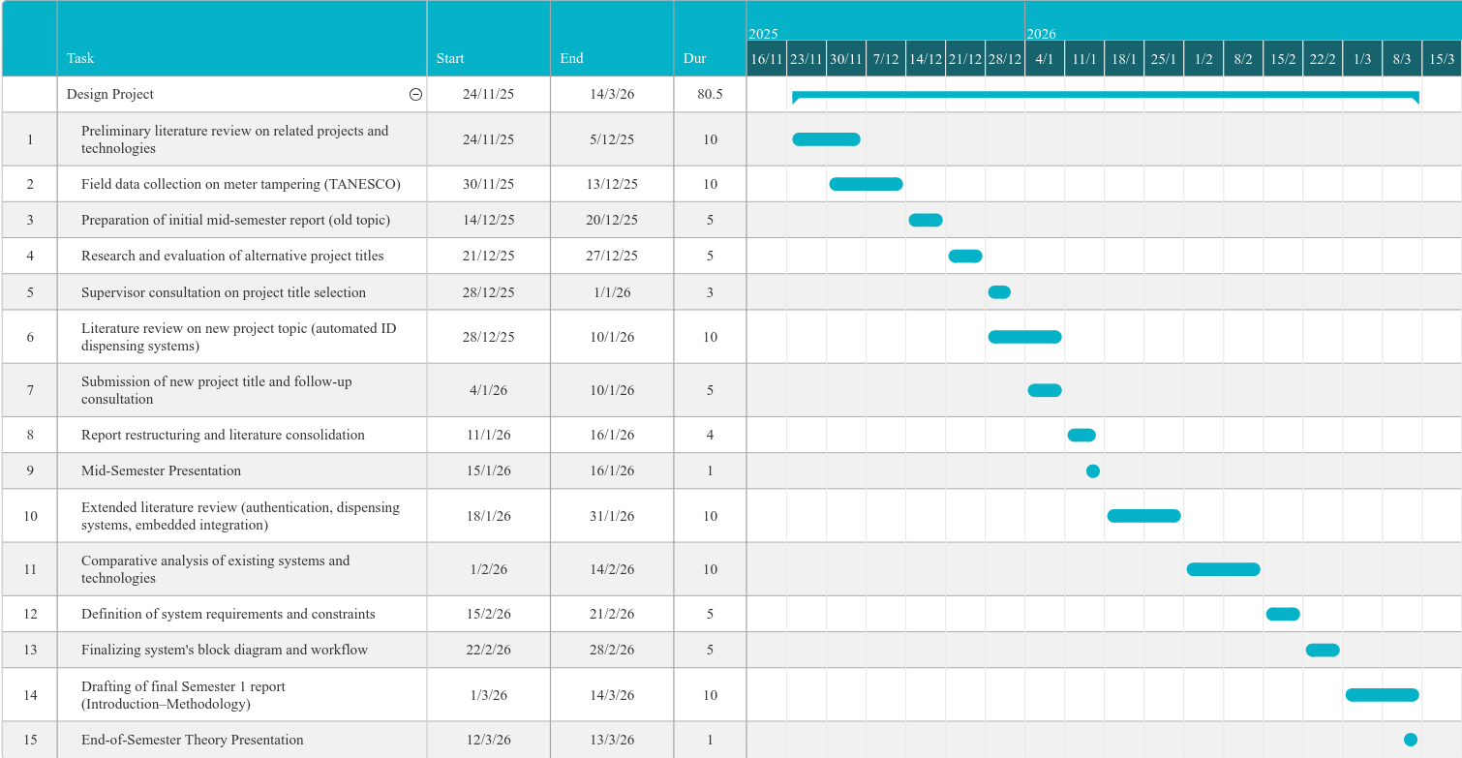
For first semester, the following Gantt chart shows various activities planned for proposed system:

For second semester, the following Gantt chart shows various activities planned for proposed system:
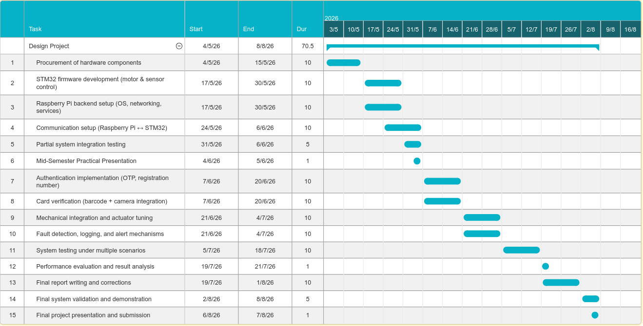
Semester 2 - Gantt Chart

3.8 PROJECT BUDGET
From the local electronics shops visited, estimated total cost of the proposed system is computed as follows:
COMPONENT | ESTIMATED COST (Tsh)
Raspberry Pi 5 (4GB) | 200,000
Low-level controller (STM32 or Arduino Due) | 50,000
Raspberry Pi Camera | 50,000
Keypad | 5,000
LCD Display | 20,000
Enclosure (mechanical parts) | 50,000
Sensors (limit switches, IR sensor, Stepper motor) | 59,200
GSM Module | 35,000
TOTAL | 469,200

REFERENCES
- Ratnasri, Nilani & Sharmilan, Tharaga. (2021). Vending Machine Technologies: A Review Article. International Journal of Sciences: Basic and Applied Research (IJSBAR). 58. 160-166.
- Aman Prasad, Shraddha Kumar, Keshav Shriram, Prof. Dr. Vikram Mane, “IOT Based Pen Vending Machine”, Published in International Research Journal of Innovations in Engineering and Technology - IRJIET, Volume 8, Issue 3, pp 367-373, March 2024. Article DOI https://doi.org/10.47001/IRJIET/2024.803057
- Peter Kibaya, Charles S Lubobya (2024) Design of a Multifactor Authentication System for Automated Teller Machines. 1: 1-17
- Xia, K., Fan, H., Huang, J., Wang, H., Ren, J., Jian, Q., & Wei, D. An Intelligent Self-Service Vending System for Smart Retail. Sensors, 21(10), 3560. https://doi.org/10.3390/s21103560

